Steps to create relational database

1. Identify the Entities

COURSE ,BATCH,STUDENT,PAYMENT,RESULTS

1. Identify the Attributes - Unique Attributes, Multivalve Attributes, Derived Attributes

COURSEID, COURSENAME ,DURATION,FEE

BATCHNO,SDATE,EDATE,NOOFSTU

REGNO,NAME,DOB,ADDRESS,TPNO

1. Identify the Relationships

COURSE BATCH STUDENT PAYMENT

receives

STUDENT

RESULTS

includes

includes

BATCH

COURSE

1. Find Cardinalities

Apply the database design concepts

1. Provide ER Diagram
2. Mapping Algorithm

If 1:M

One side primary key goes to Many Side as the foreign Key

If 1:1

Primary keys of the both sides are same

If M:N

1. Relational Schema
2. Provide Relational Database
3. Identify the Entities

Store about the objects

DEPARTMENT ,EMPLOYEE,PROJECT

1. Identify the Attributes –Attributes are used to describe the Entity

Unique Attributes, Multivalve Attributes, Derived Attributes

DEPARTMENT – DEPID, DEPNAME, LOCATION

EMPLOYEE- –EMPNO, EMPNAME, EMPADDRESS, TPNO, DOB

PROJECT- PROJECTNO, PROJECTNAME, BUDGET, DURATION

1. Identify the Relationships

DEPARTMENT includes EMPLOYEE works for PROJECT

PROJECTNO

DEPID

EMPLOYEE

PROJECT

Works for

DEPARTMENT

includes

1 M

M

N

1. Cardinality

DEPARTMENT includes EMPLOYEE

DEPID

EMPNO

1 -> Many

1 <- 1

1 : Many

EMPLOYEE works for PROJECT

EMPNO PROJECTNO

1 -> Many

Many <- 1

Many : Many

1. Mapping Algorithm

One side primary key goes to the Many side as the foreign key.

DEPID EMPNO

DEPID

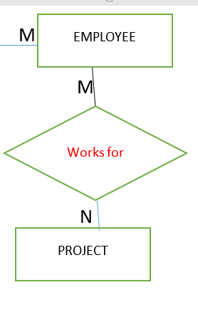

Introduce a new entity between two entities.It has a composite key

EMPLOYEE EMP_PRO PROJECT

EMPNO

PROJECTNO

Student Results

Rego Rego

|  |  |  |
| --- | --- | --- |
| Rego | name | City |
| 114 | Ann | Kandy |
| Rego | SAD | BIS |
| 114 | 56 | 85 |

1. Relational Schema

DEPARTMENT (DEPID, DEPNAME, LOCATION)

*

EMPLOYEE- (EMPNO, EMPNAME, EMPADDRESS, TPNO, DOB, DEPID)

* *

EMP_PRO(EMPNO , PROJECTNO , RATE ,DURATION )

PROJECT- (PROJECTNO, PROJECTNAME, BUDGET, DURATION)